EXPERIMENT 7
PART 2
GRANT AND REVOKE
QUERY

SELECT * FROM c24csa06.STUDENT_EXP4;
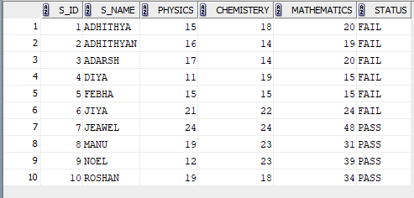

2)
INSERTING A VALUE
INSERT INTO c24csa06.STUDENT_EXP4
VALUES (11, 'ARUN', 20, 21, 22, 'PASS');

COMMIT;

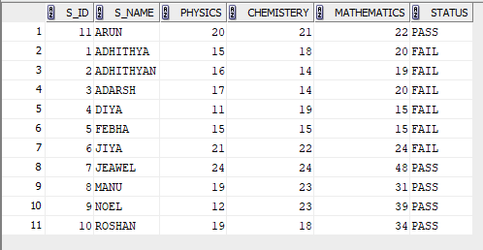

3)
GRANT
GRANT SELECT ON students_exp3 TO c24csa06 ;

4)
REVOKE
REVOKE SELECT ON students_exp3 FROM c24csa06;

